12.3.1. Description and technical characteristics of panels.
Materials used for the production of "sandwich" panels.
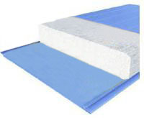 | Polyurethane foam is a light and durable waterproofing material that has a unique structure, due to which it has a low thermal conductivity and low water absorption compared to other thermal insulation materials. Polyurethane foam does not mold or rot, does not contain any nutrient base for microorganisms, has high resistance to aging, is chemically and biologically neutral, is not charged by static electricity and does not have capillary absorption.
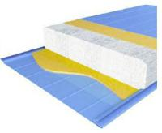 | Styrofoam is an environmentally friendly material derived from natural oil. The main component of the material is styrene, which consists of carbon and hydrogen. Styrofoam is characterized by low thermal conductivity and low density. The strength of expanded polystyrene allows it to be used as a structural element capable of carrying significant loads for a long time. Styrofoam is not hygroscopic.
Brief technical characteristics of the applied fillers:
Parameter | Polyurethane foam | Styrofoam
Density, kg/m³ | 42-70 | 15-25
Thermal conductivity, W/(m² K) | 0,022-0,026 | 0,038
Compressive strength is not less. kPa | 200 | 100

Panel facing profiles:
Panels for wall partitions and false ceilings
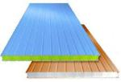 | 1. Wall panels (WP):  ‒ for internal works:  ●direct deaf panels,  ●corner panels,  ●panels with a window.  ‒ for internal works:  ●direct deaf panels,  ●panels with a window.  2. Ceiling panels (CP):  ●direct deaf panels,  ●panels with holes. | 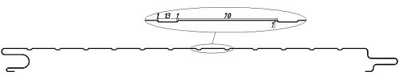
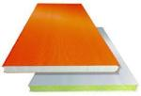
 |  | 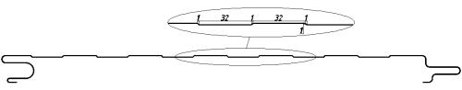
The main design dimensions of the panels:
Type of panels | Length, mm | Width, mm | Thickness, mm
WP | 3 00 ÷ 6300 | 3 00 ÷ 1100 | 50 ÷ 250
CP | 3 00 ÷ 6300 | 300 ÷ 1100 | 50 ÷ 250

Values of mass 1m², heat transfer coefficient and thermal conductivity coefficient for two-layer panels with polyurethane foam filler.
Panel thickness, mm | Thickness of a metal sheet, mm | Weight of 1m², kg | Heat transfer coefficient,  W/(m²K) | Thermal conductivity coefficient,  W/(m K)
50 | 0,45 ‒ 0,8 | 6,40 | 0,46 | 0,021 ‒ 0,026
60 |  | 6,82 | 0,39
80 |  | 7,66 | 0,30
100 |  | 8,50 | 0,24
120 |  | 9,34 | 0,20
150 |  | 10,60 | 0,16
180 |  | 11,86 | 0,13
200 |  | 12,70 | 0,12
250 |  | 14,80 | 0,10

